**PRACTICAL NO 4**

**AIM :** Develop application to consume Google’s search / Google’s Map RESTful Web service.

**SOLUTION :**

**Step 1 :** Search “console cloud google” on chrome  and sign up: <https://console.cloud.google.com>

**Step 2 :** Click on my first project and create new project

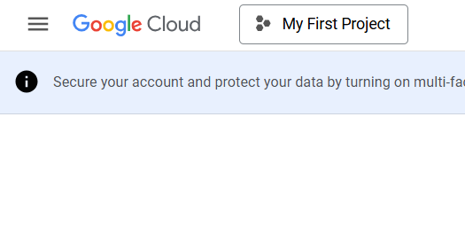

**Step 3 :** Give project name and then click create

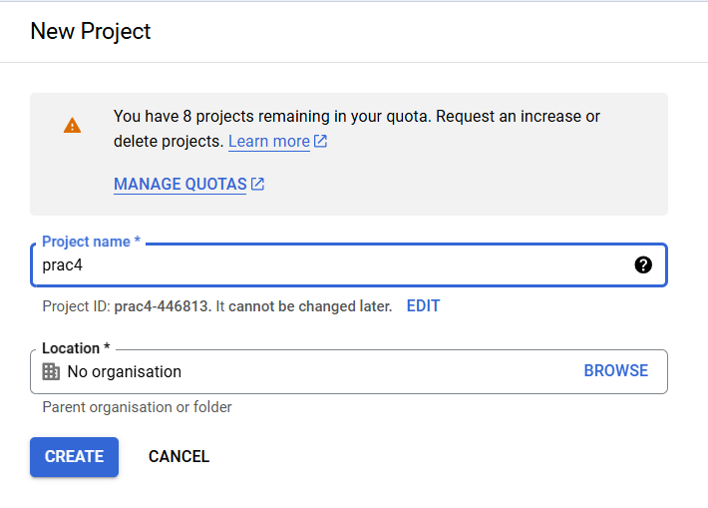

**Step 4 :** You can see your project by clicking on bell icon

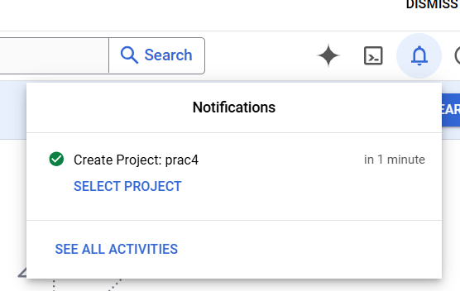

**Step 5 :** Click on bell icon and click “select project” Once you select the project then click on “APIs and Services” → Enabled APIs and services

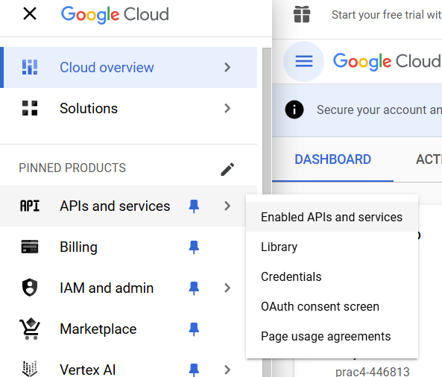

**Step 6 :** Search “Custom search api” on search bar and click on first link

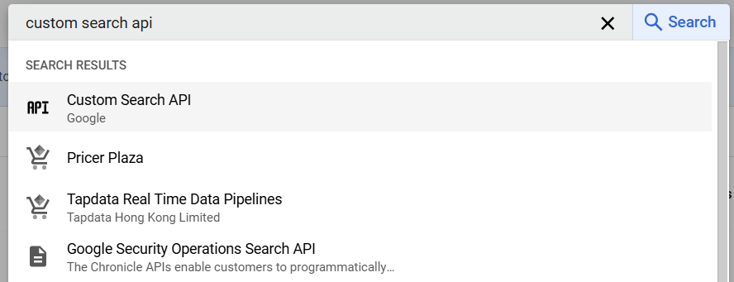

**Step 7 :** In google cloud project you always  have to specify which functionality you want  to enable.

Click on enable to enable custom search api. This enable the custom search api for this particular project

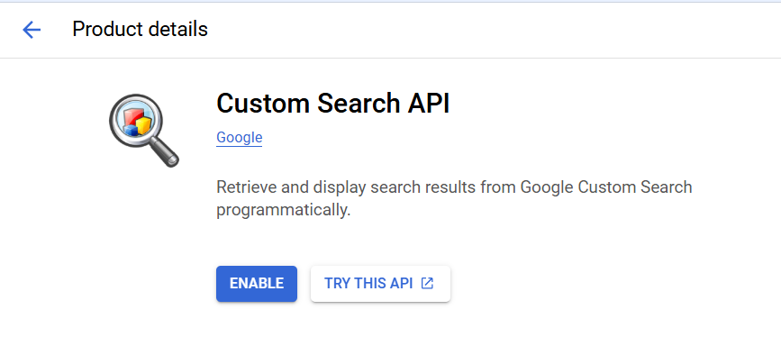

**Step 8 :** Now you  need to generate an api key to authenticate yourself from python.

In the Api & Services section click on credentials→ click create credentials → Click API key

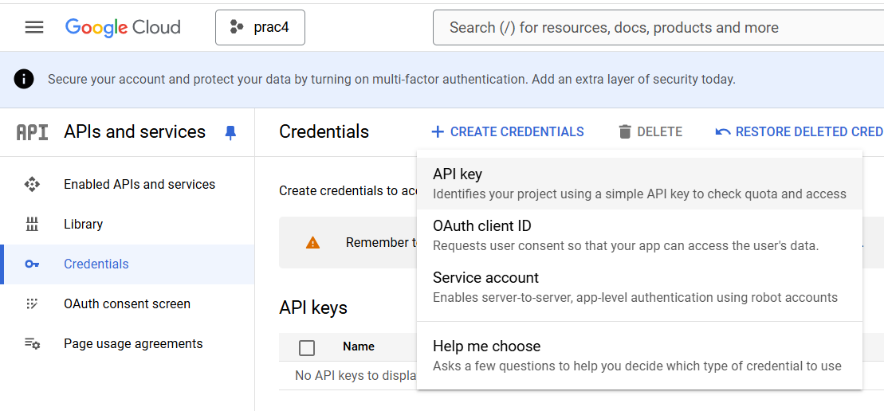



**Step 9 :** API key will be created , copy it

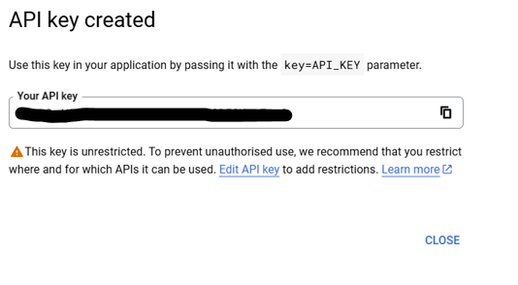

**Step 10 :** Now create a file named API_KEY inside your project folder and paste your API key value in it



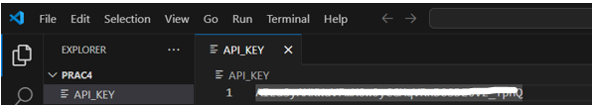

**Step 11 :** We have to Create a search engine. Navigate to the followingwebsite :

https://programmablesearchengine.google.com/about/

**Step 12 :** Click on Get started and then click on ‘create your first search engine’

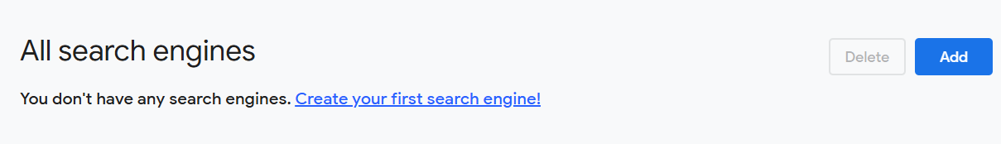

**Step 13 :** Give name to your search engine and select the "search the entire web “  and click create

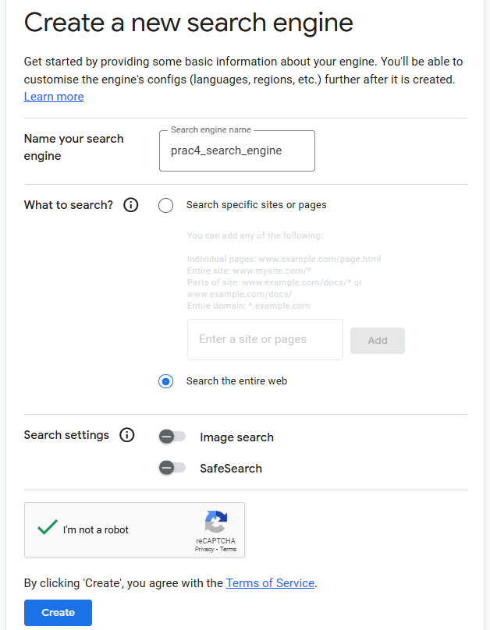

**Step 14 :** A new search engine will be created

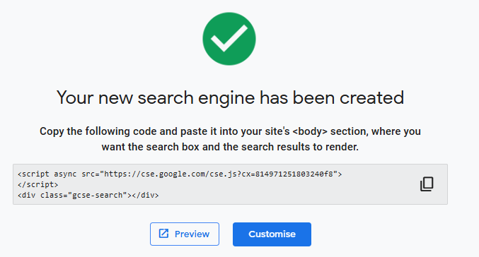

**Step 15 :** Click “go back to all search engine” → click on your search engine → Copy the search engine ID

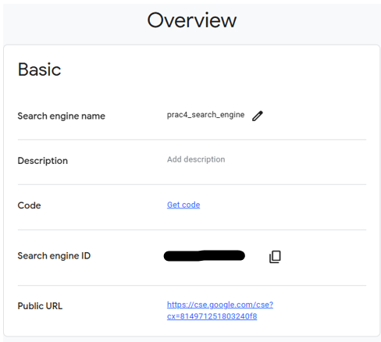



**Step 16 :** Create a new file inside your project folder as SEARCH_ENGINE_ID and paste your search engine ID

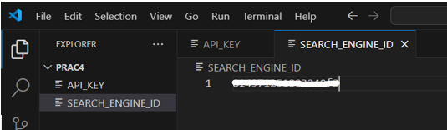

**Step 17 :** Open new terminal and Download requests using the command, pip3 install requests



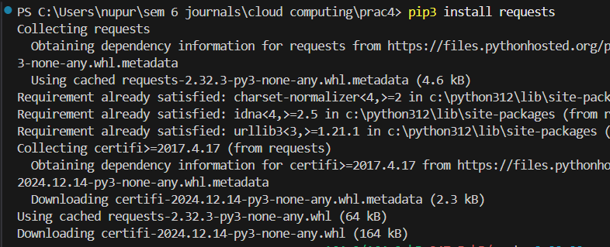

**Step 18 :** Create a file main.py and write a below code in it

**CODE:**

import requests

# Replace with your actual API key and Search Engine ID

API_KEY = 'ADD_YOUR_API'

SEARCH_ENGINE_ID = 'ADD_YOUR_SEARCH_ENGINE_ID'

search_query = 'the derma co'

url = 'https://www.googleapis.com/customsearch/v1'

params = {

    'q': search_query,

    'key': API_KEY,

    'cx': SEARCH_ENGINE_ID

}

response = requests.get(url, params=params)

results = response.json()

if 'items' in results:

    print(results['items'][0]['link'])

else:

    print("No results found.")

**OUTPUT:**

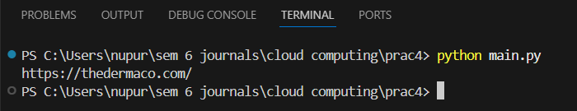

Click on the link to get the result of your search query

